Version Control Systems

Git and GitHub

Introduction
What is Git?
distributed version-control system
free and open source, supports most major operating systems including Linux, macOS, and Windows
Download
What is GitHub?
GitHub is a code hosting platform for version control and collaboration.
Multiple users work on the same file and update simultaneously
Website
Difference between Git and GitHub?
GitHub is a version control collaboration & central repository in a remote server
Git is a version control tool & local repository
GitHub Desktop
an application that enables you to interact with GitHub using a GUI instead of the command line or a web browser
Download

Elementary Concept
YouTube: https://www.youtube.com/watch?v=e9lnsKot_SQ
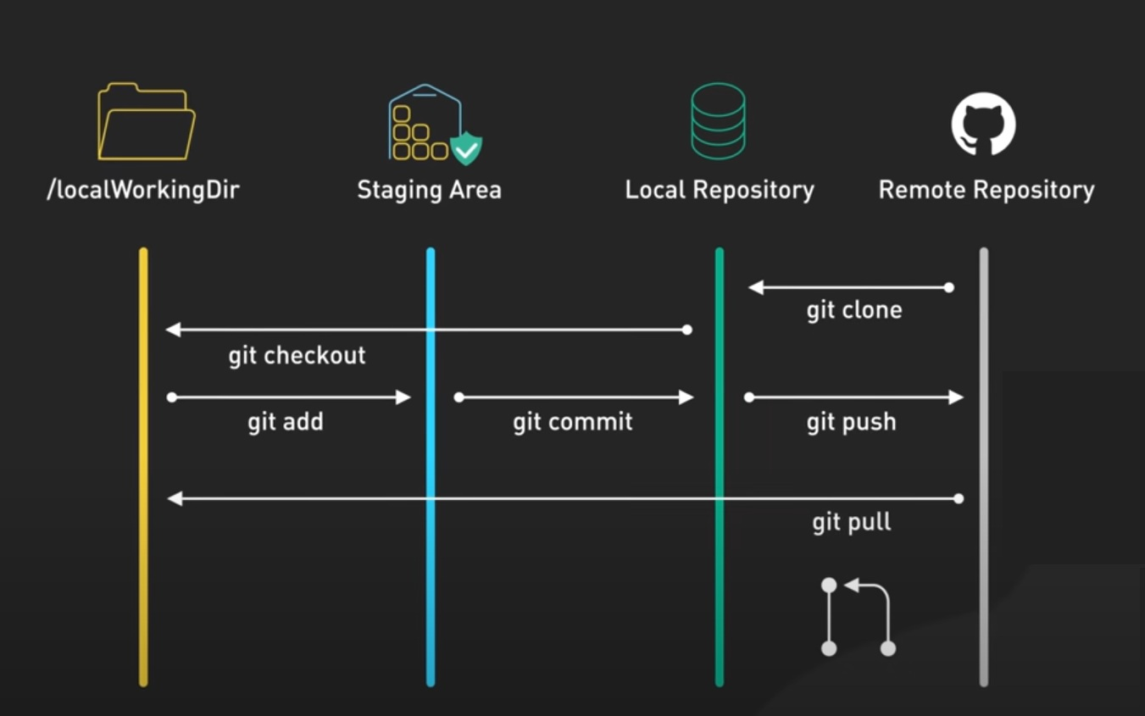
Working Directory: storage space for the project
Repository: a permanent archive holds the official history of your project, made up of all your past commits.
Commit: Saves a snapshot of your changes locally
Push: Uploads commits to the remote repository
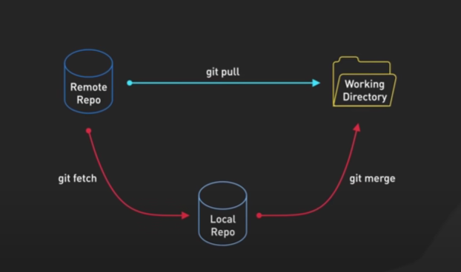
Pull: Incorporates changes from a remote repository into the current branch

Create Repository with GitHub Desktop
Introduction
GitHub Desktop is a free, open-source application that provides a graphical user interface (GUI) for Git and GitHub. It allows you to perform Git commands—such as committing, pushing, and pulling changes—without using the command line. This makes version control more accessible for beginners and those who prefer visual workflows.

Part 1: Installation and Setup
Step 1: Download and Install
- Visit the official GitHub Desktop website (desktop.github.com)
- Download the appropriate version for your operating system:
  - Windows: Click "Download for Windows" and run the installer
  - macOS: Click "Download for macOS," unzip the folder, and drag the app to your Applications folder
  - Linux: GitHub Desktop is not officially supported, but community forks are available
Step 2: Sign in to Your GitHub Account
After installation, you need to authenticate the application with your GitHub account:
- Open GitHub Desktop
- Navigate to File → Options (Windows) or GitHub Desktop → Settings (macOS)
- In the Accounts pane, click "Sign in to GitHub.com"
- Complete authorization in your browser and return to the app
Note: If you don't have a GitHub account, you can create one during the sign-in process.
Step 3: Configure Basic Settings
You can customize GitHub Desktop to suit your preferences (File ->Options):
- Integrations: Choose your preferred external text editor (e.g., VS Code)
- Git : Verify author name and email for commit attribution
- Appearance: Change themes and display options

Part 2: Core Operations
Creating a New Repository
A repository (repo) is where Git tracks all changes to your project files.
- Go to File → New Repository
- Fill in the following fields:
  - Name: Repository name (spaces are automatically replaced with dashes)
  - Description: Optional project description
  - Local path: Where the repository folder will be stored on your computer
  - Initialize with README: Recommended for new projects
  - Git ignore: Select a template based on your project type (e.g., Unity, Python)
  - License: Optionally add an open-source license
- Click "Create Repository"
Cloning a Repository
Cloning copies from a remote repository to your local machine.
- Go to File → Clone Repository
- Choose from:
  - GitHub.com tab: Browse your repositories
  - URL tab: Enter a repository URL directly
- Select a local path for the clone
- Click "Clone"
Tip: You can also clone directly from GitHub's website by clicking "Code" → "Open with GitHub Desktop".

Making Changes and Committing
- Edit files: Open the repository in your editor via Repository → Open in [Editor] or press Ctrl+Shift+A (Windows) / Cmd+Shift+A (macOS)
- Ensure you're editing files in the correct repository folder (check via Repository → Show in Explorer/Finder)
- Review changes: Return to GitHub Desktop to see modified files in the Changes tab
  - Green indicates additions
  - Red indicates deletions
- Stage changes: By default, all changes are selected. Uncheck files to exclude them
- Write a commit message: Enter a summary (e.g., "Add hello file")
- Commit: Click "Commit to main"
Important: A commit saves changes locally. To share them on GitHub, you must push.
Viewing Commit History
The History tab shows all past commits with version numbers (7-character identifiers) that uniquely identify each commit.

Part 3: Collaboration Features
Pushing Changes to GitHub
After committing, click Push origin in the top-right corner to upload your commits to GitHub. The button shows the number of commits ready to push.
Creating Pull Requests
Pull requests let you share proposed changes with others:
- After pushing your branch, click "Create Pull Request" in GitHub Desktop
- This opens GitHub in your browser to complete the pull request creation

Part 4: Undo/Revert/Reset Commits
Undo changes to the last commit
After your last commit, if you made mistakes and have the file saved but haven’t committed, you can directly discard them. This action will discard all changes and the last committed version will be restored to your working.
- Steps: In the left sidebar, make sure you are on the Changes tab. Right click the file, select the “Discard changes” option. In the confirmation window, click the Discard changes button.
Commit Not Yet Pushed — "Undo" to Resubmit
If you just made a mistake in your last commit and have not pushed it yet, you can directly undo it. This action will "undo" the commit, and the changes will be restored to your working directory, allowing you to modify and resubmit.
- Steps: In the left sidebar, make sure you are on the Changes tab. At the bottom of the sidebar, click the Undo button. Or, you can right click the last commit in the History panel and select Undo commit
- Note: If you need to undo multiple consecutive commits, you can right-click a previous commit in the History panel and select Reset to commit to restore the changes from all subsequent commits to your working directory.
# You can use the ‘Discard changes’ method discussed above to discard changes if you want to get back the ‘clean’ version.
Commit Already Pushed — Use "Revert"
If the commit has already been pushed to the remote repository, do not use Undo or Reset, as this will rewrite history and cause serious problems for collaborators. The correct approach is to create a new commit that "reverses" the changes from that commit. This preserves the original commit record and safely undoes its changes.
- Click the History tab in the left sidebar.
- Find the commit you want to undo, right-click on it, and select Revert Changes in Commit.
- GitHub Desktop will automatically generate a new commit with a "Revert" prefix, containing changes that undo the previous commit. You just need to push this new commit to the remote repository. This action will "discard" all the changes in the last commit and a ‘clean’ version of the second last commit will be restored to your working directory.

Part 5: Branch Management
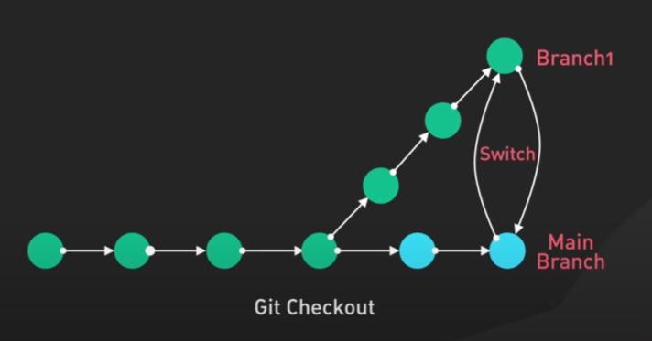
Branch: an independent line of development let you work on different versions of a repository. Branches allow you to work on features or fixes in isolation without affecting the main codebase.

Creating a Branch
- Click the Current Branch dropdown at the top
- Click "New Branch"
- Enter a name and create it
Switching Branches
Click the Current Branch dropdown and select the branch you want to work on.

Merging Branches
To merge a branch into your main branch using GitHub Desktop, select your main branch first, then choose the branch you want to merge into it.
Before you start, make sure you have saved and committed any active work on your current branch.
Step-by-Step Instructions
- Switch to the main branch: Click on the Current Branch dropdown at the top centre of the screen and select main (or master).
- Pull the latest changes (Optional): Click Fetch origin (and then Pull origin if updates are available) in the top right. This ensures your local main branch is completely up to date.
- Open the merge menu: Click the Branch dropdown menu. At the very bottom of the menu, click the Merge into current branch option.
- Select your feature branch: A list of branches will appear. Click on the feature branch that contains the work you want to bring into main.
- Complete the merge: If no "Merge Conflicts", click the big blue Create a Merge Commit button at the bottom.
- Push to GitHub.com (optional): Click Push origin at the top right to upload the newly merged changes from your computer to the live GitHub repository.
What to do if you see "Merge Conflicts"
If the same line of code was changed on both branches, GitHub Desktop will block the merge and show a warning.
- The Fix: GitHub Desktop will list the conflicted files. Click Open in [Your Editor] (like VS Code).
- The Choice: Inside your editor, look for the highlighted code and choose whether to keep your branch's changes, main's changes, or both.
- The Finish: Save the file, return to GitHub Desktop, and click Commit Merge.
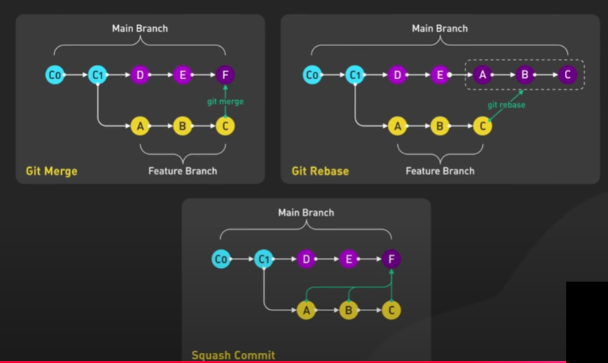
Different types of merges that merge the feature branch into the main master branch
Note: In Git Merge, the new born Merge Commit F now has two parents; Commit E and Commit C. In Git Rebase, the Commit E is the parent of the new born merge commit formed by the features branch.

Using Git through Command Line (Optional)
- Install git and create a GitHub account
After you have downloaded and installed git, open a command console and type
$ git --version
You can check git version if it installed successfully. Type
$ git help #to get online help
We need to let git knows your name and email address so that it can add this information to the author’s information of a committed file.
$ git config --global user.name “MyName”
$ git config --global user.email “my.name@cityu.edu.hk”
- Create a local git repository
To initialize a git repository in the root of your project folder, run the git init command:
$ mkdir myproject # if the project folder not exist
$ cd myproject
$ git init
An. hidden .git folder will be created which store the log records of the change history. Don’t delete it!
- Add some new files to the repository
$ clear #clear the screen
Using an editor, create three new python files (demo1.py, demo2.py and demo3.py) in the project folder and use the git status command to see the status of your git repository. Type
$ git status
You should only have one branch; the default master branch and all files should be untracked and no commit file.
To track the changes on a specific file, we need to put the file into the staging environment first. Type
- Add files to the staging environment
$ git add demo1.py
Type git status command again, you should have the demo1.py on stage.
To put all the python files on stage, type
$ git add demo2.py demo3.py
- Create a commit
Now we want to take a snap on the tracked file so that you can make changes on these files without worrying about not having backup. Type “commit -m 'Your message about the commit” command:
$ git commit -m 'All files; Ver1.0 '
Now we can make some changes to these files. For example, put some comments on demo1.py and demo3.py.
To have second commit version of these modified files, we need to add them on stage and take a snap.
$ git add demo1.py demo3.py
Or
$ git add . #only modified files will be added
Type commit command to take a snap on the 2nd version of these modified files.
$ git commit -m 'demo1 & demo3; Ver2.0 '
- Create a new branch
Run git checkout -b <my branch name> to create a new branch and then check you out on it.
$ git checkout -b branch1
You can make changes and commit on the demo files. Make some changes on demo2.py and take a snap.
$ git add .
$ git commit -m 'demo2; Ver2.1 '
- Create a new repository on GitHub
Sign-in/sign-up GitHub and create a new repository.
- Push the local repository to GitHub
First, add a bookmark ‘origin’ of the remote GitHub repository.
$ git remote add origin https://github.com/<username>/<repositoryname>.git
then
$ git push -u origin master
Note: The -u modifier make the origin and master as the defaults
To push changes on a specific branch to GitHub, use git push <remote-name> <local-branch-name>. In our case, type:
$ git push origin branch1
Now we have backup all the commits on master and branch1 to the remote repository. You can switch to another branch by typing git switch <branch-name>
$ git switch master
Open the demo2.py file. It is still the old copy of “Ver1.0”. Make some changes and then commit the change.
$ git add .
$ git commit -m 'demo2; Ver2.0 '
- Do some modifications on demo2.py and then save it. To undo the modification to a specific file, use git checkout -- <filename>
$ git checkout -- demo2.py
The changes on demo2.py should be reverted back to Ver2.0
- To reverse the changes to a specific previous commit
$ git revert <commit-hash>
The <commit-hash> can be viewed by using the command git log.
If you just revert the most recent commit, use the command git revert HEAD
- To merge the changes on the feature branch to the master branch
$ git switch master # needed if you are not in the master branch
$ git merge branch1
You should result a merge conflict. Open the demo2.py file and edit the file to resolve the conflict. Then:
$ git add demo2.py
$git commit -m 'demo2; Ver2.01'
- Get changes on GitHub back to your computer
To get the most recent changes that you or others have merged on GitHub, type
$ git pull origin master
# Merge conflicts may occur, needed to be solved before merge successfully.

